UI/UX DESIGN ANALYSIS REPORT– MEESHO Mobile Application

OBJECTIVE:

Meesho aims to provide affordable online shopping while empowering small businesses and resellers through a simple and accessible platform.

INTRODUCTION:

Meesho is an Indian e-commerce app that allows users to shop for a wide variety of products at affordable prices. It also helps small businesses and individuals sell products online with ease. The app offers a simple, user-friendly experience with secure payments and convenient home delivery.

1.NAVIGATION STRUCTURE

FEATUERS:

Bottom navigation bar (Home, Categories, Orders, Cart, Account)
- Search bar with product suggestions
- Category-wise product browsing
- Filter and Sort options
- Product detail pages
- Shopping cart and checkout
- Order tracking
- Easy back navigation

ANALYSIS:

The navigation requires very few steps to access important features, reducing user effort and making the application easy to learn .

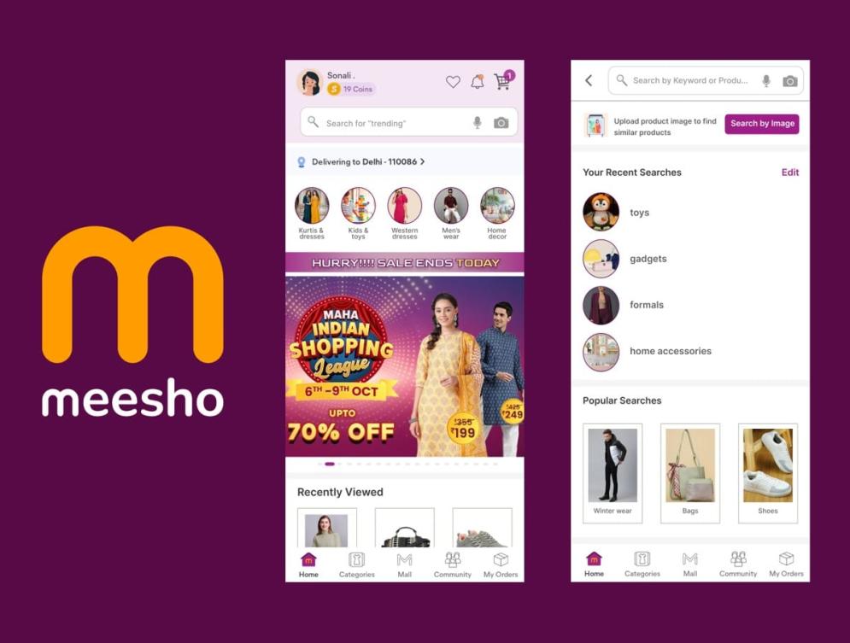

2. LAYOUT ORGANISATION

The Meesho app has a well-structured and user-friendly layout that helps users easily browse, search, and purchase products with minimal effort.

FEATURES:
- Consistent layout across all pages
- Bottom navigation bar for easy access
- Grid-based product display
- Clear product images with price and ratings
- Well-organized categories
- Promotional banners placed at the top
- Easy-to-read fonts and proper spacing
- Responsive design for different screen sizes
ANALYISIS :
- Products are easy to find.
- Categories are well organized.
- Buttons and icons are easy to use.
- Easy to read and navigate.
- Provides a smooth shopping experience.

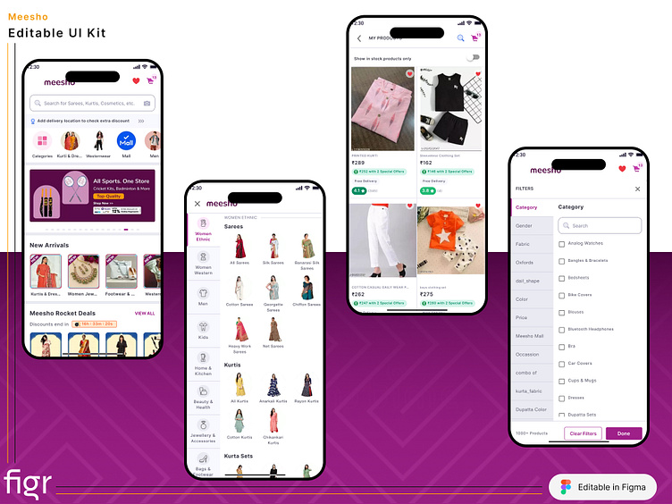

3.COLOUR SCHEME:
- Purple
- White
- Black
- Light Gray
- Pink(for highlights and offers)

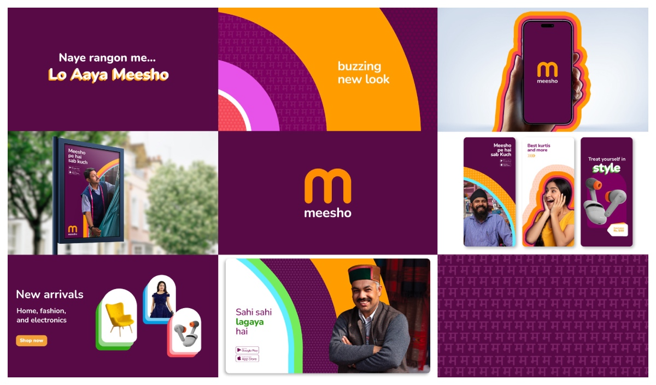

ANALYSIS:
- Uses attractive and consistent colors.
- Purple gives the app a unique brand identity.
- White background improves readability.
- Colors highlight important buttons and offers.
- The overall color scheme is clean and user-friendly.

4.TYPOGRAPHY:
Meesho uses a simple, clear, and consistent sans-serif font for easy readability.

FEATURES:
- Simple sans-serif font
- Clear and readable text
- Bold headings and prices
- Consistent font style
- Proper text spacing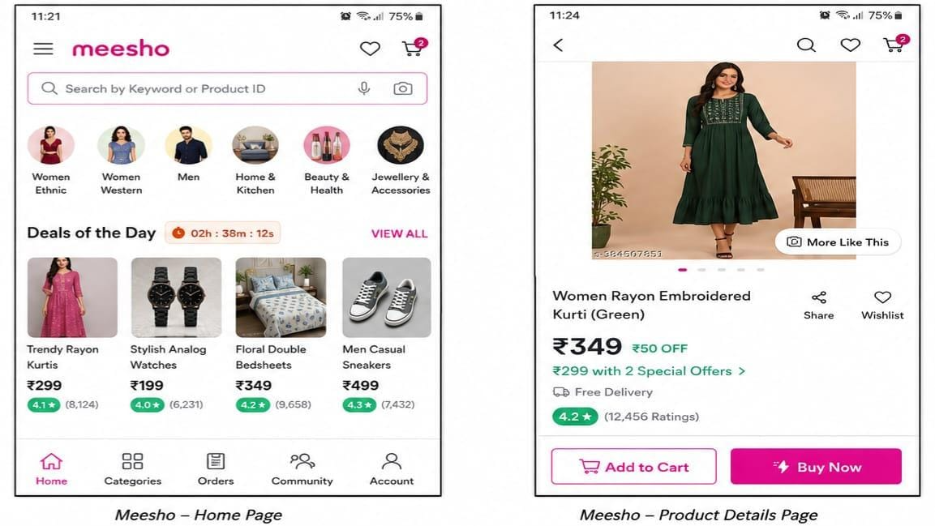

ANALYSIS:
The typography is clear, consistent, and easy to read, improving the overall user experience.

5.USER FLOW:

User Flow – Meesho App (Example: Buying a Product)
Open Meesho
↓
Search or Select Product
↓
View Product Details
↓
Add to Cart
↓
Proceed to Checkout
↓
Make Payment / Place Order
↓
Order Confirmed
↓
Track Order

Analysis : The user flow is simple and easy to follow. Clear navigation and step-by-step checkout make shopping quick and convenient.

UI ElEMENTS IDENTIFIED:

UI ELEMENT | PURPOSE
Buttons | Add to cart, buy products, and perform actions
Icons | Search, Cart, Wishlist, Profile, Orders
Search Bar | Find products quickly
Navigation Bar | Switch between Home, Categories, Orders, Cart, and Account
Product Cards | Display product image, price, and details
Categories | Browse products by category
Banners | Highlight offers and discounts
Notifications | Inform users about orders, offers, and updates

UX FEATURES:
- Fast app performance.
- Easy to use for new users.
- Simple and consistent interface.
- Smooth navigation between screens.
- Responsive touch interactions.
- Secure payment process.
- Quick product search and filtering.
- Easy order tracking.
- Attractive product recommendations.
- Minimal loading time.

STRENGTHS:
- Simple and clean user interface.
- Easy product navigation.
- Fast and smooth performance.
- User-friendly design.
- Attractive color scheme.
- Affordable product options.
- Easy search and filtering.
- Secure payment process.
- Simple order tracking.
- Excellent overall shopping experience.

WEAKNESS:
- Too many ads and promotional banners.
- Product quality may vary between sellers.
- Delivery can be delayed in some areas.
- Search results are sometimes not accurate.
- Return and refund process may take time.
- UI vs UX Observation – Meesho App
UI (User Interface) | UX (User Experience)
Purple color theme | Easy and enjoyable shopping
Product cards | Quick product browsing
Bottom navigation | Simple navigation
Search bar | Fast product search
Icons | Easy feature recognition
Clean layout | Smooth shopping experience

SUGGESTION:
- Improve product search accuracy.
- Reduce unnecessary ads and promotional banners.
- Ensure consistent product quality.
- Speed up delivery and refund processes.
- Add more personalized product recommendations.

LEARNING OUTCOMES:
Through this experiment, I learned how to evaluate the UI and UX of the Meesho app based on usability principles. I understood the importance of navigation, layout, typography, color scheme, and user flow in creating a better shopping experience. Meesho shows how a simple and user-friendly design improves usability and customer satisfaction.

CONCLUSION:
Meesho is a well-designed e-commerce application with a clean interface, simple navigation, clear typography, and an attractive color scheme. Its user-friendly design makenlinehopping easy and convenient. Although there is room for improvement, Meesho effectively follows key UI/UX design principles and provides a smooth shopping experience.

